#### 

**Veritas Backup Exec**

**Plugin Configuration Guide**

Contents

Backup Exec Configuration Checklist 2

Supported Collection Types 2

Data Sources 2

Requirements 3

Backup Exec Ports 3

Backup Exec SQL Database 3

Backup Exec Log Files 3

Setup 4

Server Properties 4

Field Definitions 4

Troubleshooting 7

Technical Support 8

# Backup Exec Configuration Checklist

While detailed steps are included below, this is an overview of the steps to configure Backup Exec collections on your Bocada Data Collection Server:

* Verify required TCP ports have been opened.
* Verify location of the Backup Exec database.
* If necessary, create a SQL login with Read access on that database.
* Verify locations of the log files.

# Supported Collection Types

The plugin currently supports the following collection types from Backup Exec servers:

|  |  |  |
| --- | --- | --- |
| **Collection Type** | **Supported** | **Description** |
| Backup* | ✓ | Collects transactional details about backup, duplication and restore jobs. Example metrics include, start times, durations, bytes, files, errors etc. |
| Storage | ✓ | Collects point-in-time inventory information. Example metrics include, total recoverable gigabytes (Storage), media volume count, media volume status, etc. |
| Policy | ✓ | Collects and stores information on policy attributes, schedules, storage units, storage groups, storage lifecycle policies and clients. |

**\* Note:** The *VM Protection Analysis* report displays Virtual Machines (VMs) in the environment, showing data protection status (or lack thereof) for each VM, and will indicate if those VMs are protected by snapshots, backup applications, or are exposed as unprotected.  This feature is supported for several backup applications, including Backup Exec.

When both vCenter and Backup Exec Backup Servers have been added to Bocada, Backup updates on both will also correlate Backup Exec client data with vCenter virtual machine data, in the following scenario:

* The Backup Exec server backup client is a virtual machine managed by vCenter.
* The vCenter virtual machines have been added to Bocada data collection and previously inventoried using the vCenter plugin in Bocada.

# Data Sources

The plugin relies on the following Backup Exec data sources:

* Backup Exec SQL Database Connection
* Backup Exec log files

# Requirements

This section lists requirements that must be met prior to collecting data with the Bocada plugin for Backup Exec. Note that Backup Exec versions 2010x and earlier require the Bocada Backup Exec Legacy plugin.

## Backup Exec Ports

|  |  |  |
| --- | --- | --- |
| **Service** | **Default Port** | **Note** |
| *SMB* | 445/TCP | For optional access to log files |
| *SQL Server* | 1433/TCP | - |
| *SQL Server browser* | 1434/UDP | Not required when default SQL port specified |

The Bocada Data Collection Server must be able to connect to the Backup Exec server on the port(s) that the Backup Exec software responds to. By default, the TCP port for a Backup Exec server is 1433.

## **Backup Exec SQL Database**

The plugin relies on access to the Backup Exec database to collect backup, storage and policy data.

## **Backup Exec Log Files**

#### Location

The plugin uses data files on the Backup Exec server created during backup in order to collect secondary job information. Collections will succeed, and job Success/Failure data will be collected, with access to the Backup Exec SQL database only; however, more detailed job messages indicating *why* those jobs succeeded or failed, as well as virtual machine information, are found in the log files.

When using vCenter, Bocada uses this log file information to tie the Backup Exec client data to virtual machine data for display in vCenter reporting.

The default Backup Exec location varies depending on when you obtained it, and is often C:\Program Files\Symantec\Backup Exec\Data. The preferred method is to provide the plugin with the path and a login with read access to the Backup Exec log files. As an alternative, the plugin can determine the Backup Exec log file location by reading the Windows Registry.

*Note: In order to read the Windows Registry, the plug-in requires Administrator access. This level of access is not required if the plugin is provided the path to the log files.*

# Setup

## Server Properties

Backup Server Properties determine how the plugin will interface with the Backup Exec server.

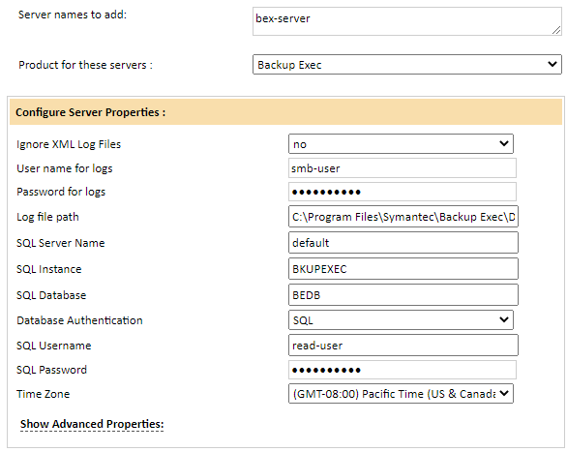

## Field Definitions

#### Server Names to add

Enter the name of the Backup Exec server. If you use CASO (Central Administration Server Option) then the plugin should collect data for all backup clients from the Master CASO server only. There is no need to connect to individual Managed Backup Exec server / media servers that are under a CASO server.

You can define multiple Backup Exec servers (also for CASO) by entering them in separate lines or comma separated.

#### Ignore XML Log Files

Used when the log files are not available to prevent the plug-in from attempting to access them.

#### User Name & Password for Logs

Used for Backup job messages and VM/Client correlations. Enter a username and password that the plugin will use to access the Backup Exec .xml log files on the backup server. This should be in the form of [Domain]\ [UserName]. If a user credential local to the machine will be used, then the form should be [BackupExecServerName]\[LocalUserName].

#### Log File Path

Used for Backup job messages and VM/Client correlations. Provide the path to the directory containing the Backup Exec log files. A default path (‘C:\Program Files\Symantec\Backup Exec\Data’) is entered by the plugin, but it may need to be updated to match the Backup Exec server. Entering a path directs the plugin to look in the specified location, requiring only Read access to the location of the log files.

*Note: Do not include the server name in the Log File Path as it is automatically added by the plugin.*

#### SQL Server Credentials

Used for Backup job data, and all other collection types. Enter the properties to access the SQL server:

* SQL Server Name (Default is the Backup Exec Server).
* Instance (if applicable; Default is ‘BKUPEXEC’).
* Database Name (Default is ‘BEDB’).
* Database Authentication method (Defaults to SQL auth).
* SQL Username and password with access to the database (Defaults to the ‘sa’ user).

#### Time Zone

Select the time zone of the Backup Exec server. This setting ensures times are displayed consistently in environments that span multiple time zones.

# Troubleshooting

The following notes cover some items to check if Test Connection or Data Collection do not succeed for the Backup Exec plugin. For assistance with these and other issues, please contact Bocada Support.

#### Data Collection succeeds, but no data is collected.

Confirm the version of Backup Exec. Versions older than Backup Exec 2012 require the Backup Exec *Legacy* plugin. If the server is running an older version of Backup Exec, add your Backup Exec server to Bocada via the Backup Exec Legacy plugin.

#### Test Connection Fails

Confirm the user entered in the Server Properties has access to the Backup Exec log files and that the password is correct.

On the Backup Exec server, confirm the SQL Browser service is running, and set to Automatic.

#### Allowing SQL authentication access to the Backup Exec SQL instance:

These steps may be necessary if the default SQL user ‘sa’ is locked down:

1. In SQL Server Management Studio, connect to the Backup Exec SQL instance (defaults to ‘BKUPEXEC’)
2. Enable SQL authentication (mixed mode):
   1. Right-click on the instance and select *Properties*
   2. In the Server Properties window that appears, select *Security*
   3. Under *Server authentication*, select *SQL Server and Windows Authentication mode*
   4. Click *OK*.
3. Add a new user with SQL authentication:
   1. In the SSMS Object Explorer, click on the plus icon next to *Security* to expand
   2. Right-click on *Logins* and select *New Login*
   3. In the new Login window that appears, on the General tab:
      1. Select the *SQL Server authentication* button.
      2. Enter the login name and a password which meets your password policy.
   4. On the Server Roles tab: Select the appropriate role.
   5. On the User Mapping tab:
      1. Select your Backup Exec database (‘BEDB’)
      2. Select the appropriate membership roles (Read access should be sufficient)
   6. On the Status tab:
      1. Verify Permission to connect is *Granted*
      2. Verify Login is *Enabled*

# 

# Technical Support

For technical support or a copy of our standard support agreement, please contact us.

**E-mail:** [support@bocada.com](mailto:support@bocada.com)

**Support Portal:** <https://bocada-support.force.com/>

**Phone:** +1-425-898-2400